Name _____________________________________________

**Unit 7: Roaring 20s**

* Review Pages & Study notebooks - **Due - T- 4/2/19**
* **Unit Test - T- 4/2/19**

|  |  |  |  |
| --- | --- | --- | --- |
| **Date** | **Homework** | **Aim** | **Answer to Aim** |
| Th-  3/21/19 | Read, highlight, and annotate “The Roaring Twenties” essay by Joshua Zeitz on p. 6-9. Annotate for key terms and phrases and also note questions and comments about the reading. Write a one to two-sentence summary of each section. There is a glossary at the end of the reading. | How did the social changes of the 1920s reflect a conflict between “traditional” and “modern” values? |  |
| F-  3/22/19 | Answer the question, "How was the Scopes “Monkey” Trial more than a simple debate between science and religion in 1920s America?" in paragraph form. Use information from your class notes, the film excerpt, and at least 3 documents. **POST ON GOOGLE CLASSROOM.** | How was the Scopes “Monkey” trial more than a simple debate between science and religion in 1920s America? |  |
| M -  3/25/19 | Write one paragraph that answers the question: Why did America change its mind about Prohibition? Use information from the background essay on p. 15 AND information from at least THREE documents on p. 16-19 in your response. FOLLOW THE ICE FORMULA. **POST ON GOOGLE CLASSROOM.** | Why did America change its mind about Prohibition? |  |
| T- 3/26/19 | Complete vocabulary review activities on p. 26, 27,37, and complete the Writing Activity outline on p. 38 | Was the Red Scare of 1919-1920 a dangerous over-reaction or necessary for national protection? |  |
| W-  3/27/19 | Read, highlight, and annotate: *The New Era: Culture War* on p. 55 | How and why did the U.S. government bring the peak era of immigration to the U.S. to an end in the 1920s? |  |

|  |  |  |  |
| --- | --- | --- | --- |
| Th-  3/28/19 | Make sure charts on p. 61 & 62 are complete. Complete outline sheets on p. 63 & 64. | What caused the Chicago race riots of 1919? |  |
| F-  3/29/19 | Complete outline on p. 71. | How did the Harlem Renaissance reflect the lives and celebrate the culture of African-Americans in the 1920s? |  |
| M-  4/1/19 | Read and highlight Main Topics on p. 69. Define Important terms & Identify people and answer study questions on p. 72 in study notebook. Due: Tuesday, 4/2/19. | Review |  |
| T-  4/2/19 |  | Test |  |
|  |  |  |  |
|  |  |  |  |

**Statistics 1920 1930**

Population of the United States 106 million 123 million

Life expectancy in years:

White male 56.3 59.1

White female 58.5 62.7

Black male 47.1 46.9

Black female 47.6 49.5

Deaths per 100,000 persons:

From measles 8.8 3.2

From automobile accidents 10.3 26.7

Number of homicides 5,815 10,331

Number of horses 19.7 million 13.5 million

Number of high school graduates 311,000 667,000

Number of bowlers (people who bowl) 27,000 219,000

Passenger cars sold 1,905,500 2,787,400

Number of radio stations 1 618

Percentage of homes with electricity 35% 68%

*Describe at least three statistical changes that occurred in the U.S. between 1920 and 1930. For each, make an* ***inference*** *about what the meaning of this change might be. An example is given for you below.*

|  |  |
| --- | --- |
| **Statistical change** | **Possible significance** |
| * *The number of homicides almost doubled from 5,815 to 10,331.* | * *The United States was becoming a more violent place to live.* |
|  |  |
|  |  |
|  |  |
|  |  |
|  |  |

**Vocabulary Activity**

***Match the following words to their definitions:***

1. Prohibition ____ A. young women of the 1920s who went against conventional ideas about behavior and style, and embraced a new style

2. Temperance ____ B. the time between 1919 and 1933 during which alcohol was banned in the United States

3. flappers ____ C. smugglers who made or sold alcohol illegally during Prohibition

4. bootleggers ____ D. soberness; also the name of a social movement against drinking alcohol

5. speakeasy ____ E. a bar which sold alcohol illegally during Prohibition

6. nativism ____ F. the scientific theory that animals (including) humans evolved over millions of years through natural selection

7. creationism ____ G. an anti-immigrant movement that said people born in the U.S. (“natives”) should get preference over immigrants

8. evolution ____ H. the belief that God created the world in 7 days

The Roaring Twenties

* Annotate for key terms/phrases
* Note questions & comments about the reading

by Joshua Zeitz

**From the Gilder Lehrman Institute for American History**

**https://www.gilderlehrman.org/history-by-era/roaring-twenties/essays/roaring-twenties**

The 1920s heralded a dramatic break between America’s past and future. Before World War I the country remained culturally and psychologically rooted in the nineteenth century, but in the 1920s America seemed to break its wistful attachments to the recent past and usher in a more modern era. The most vivid impressions of that era are flappers and dance halls, movie palaces and radio empires, and Prohibition and speakeasies. Scientists shattered the boundaries of space and time, aviators made men fly, and women went to work. The country was confident—and rich. But the 1920s were an age of extreme contradiction. The unmatched prosperity and cultural advancement was accompanied by intense social unrest and reaction. The same decade that bore witness to urbanism and modernism also introduced the Ku Klux Klan, Prohibition, nativism, and religious fundamentalism. America stood at a crossroads between innovation and tradition. Many Americans were looking boldly ahead, but just as many were gazing backward, to cherished memories of a fabled national innocence.

**Age of Convergence**

Many of the trends that converged to make the twenties distinct had been building for years, and in some cases, decades.

We think of the twenties as an era of liberation for women. Indeed, the decade gave rise to the flapper, described by *Webster’s Collegiate Dictionary* as “a young girl, esp. one somewhat daring in conduct, speech and dress,” immortalized in the short stories of F. Scott Fitzgerald and by silent film stars like Clara Bow, Colleen Moore, and Louise Brooks. But women had been breaking down the separate spheres of Victorian culture for quite some time. A powerful women’s political movement demanded and won the right to vote in 1920. Spurred on by the growth of an urban, industrial economy that required a larger female labor force, and by the emergence of public amusements that defied the old nineteenth-century courting system, many young women now had the wherewithal and drive to lead independent lives. By the dawn of the decade, anywhere between one-quarter and one-third of urban woman workers lived alone in private apartments or boardinghouses, free from the watchful eyes of their parents, and as early as 1896, newspaper columnist George Ade used the term “date” to describe a new convention by which boys and girls paired off to frolic at dance halls, amusement parks, and other public spaces, free from adult supervision….

We think of the twenties as an era of prosperity, and in many respects, Americans had never lived so well. But this trend, too, claimed earlier roots. As factories and shops mechanized, the work week of the urban blue-collar worker fell from 55.9 hours in 1900 to 44.2 in 1929, while his or her real wages rose by 25 percent. By the dawn of the twenties, Americans had more time and money to spend on new kinds of public amusements like dance halls, movie theaters, fun parks, and baseball stadiums. They also had more opportunities to buy competitively priced durable items, thanks to new methods of production and distribution. The prosperity of the post-war period greatly accelerated this trend. By 1929, American families spent over 20 percent of their household earnings on such items as phonographs, factory-made furniture, radios, electric appliances, automobiles, and “entertainment.” What people couldn’t afford, they borrowed. By the mid-’20s Americans bought over three-quarters of all furniture, phonographs, and washing machines on credit.

The proliferation of advertising—alongside the maturation of the publishing, music, and film industries—exposed citizens to a new gospel of fun that was intimately associated with the purchase of goods and services. “Sell them their dreams,” a prominent ad-man intoned. “Sell them what they longed for and hoped for and almost despaired of having. Sell them hats by splashing sunlight across them. Sell them dreams—dreams of country clubs and proms and visions of what might happen if only. After all, people don’t buy things to have them. . . . They buy hope—hope of what your merchandise might do for them.”1

**Age of Wonders**

If many of the social trends that we associate with the twenties had long been building, the decade was indeed unique in many ways.

It was a decade of firsts. For the first time ever, more Americans (51 percent) lived in cities than in villages or on farms.

It was a decade of economic expansion. Between 1919 and 1929 horsepower per wage earner in manufacturing skyrocketed by 50 percent, signaling a robust wave of mechanization that increased productivity by 72 percent in manufacturing, 33 percent in railroads, and 41 percent in mining.

And it was a decade of technological wonder.

In 1912, only 16 percent of American households had electricity; by the mid-20s, almost two-thirds did. Overnight, the electric vacuum cleaner, the electric refrigerator and freezer, and the automatic washing machine became staples in middle-class homes.

At the dawn of the twentieth century, automobiles were still unreliable and scarce, but in the years just prior to World War I, pioneers like Ransom Olds, Henry Leland, and Henry Ford revolutionized design and production methods to make the car affordable and trustworthy. When the sociologists Robert and Helen Lynd interviewed high school students in Muncie, Indiana, in the mid-20s, they found that the most common sources of disagreement between teenagers and their parents were 1) “the number of times you go out on school nights during the week”; 2) “the hour you get in at night”; 3) “grades at school”; 4) “your spending money”; and 5) “use of the automobile.”2

Another pre-war technology that came of age in the twenties was film. By the mid-1920s movie theaters were selling 50 million tickets each week, a sum equal to roughly half the US population! And the generation that came of age in the twenties learned things at the movie palace that they couldn’t learn in school. “The only benefit I ever got from the movies was in learning to love and the knowledge of sex,” a young woman confided to an interviewer in the mid-20s. “If we didn’t see such examples in the movies,” explain another, “where would we get the idea of being ‘hot?’ We wouldn’t.”3 These young informants might have been thinking of the 1923 blockbuster *Flaming Youth*, which one reviewer described as “intriguingly risqué, but not necessarily offensively so. The flapperism of today, with its jazz. . . . and its utter disregard of the conventions, is daringly handled in this film. And it contains a bathing scene in silhouette that must have made the censors blink.”4

Like film, radio was invented in the late nineteenth century but experienced its formative era of commercial expansion in the twenties. On November 2, 1920, radio station KDKA in Pittsburgh, Pennsylvania, broadcast the presidential election returns. It was the first-ever live radio transmission for a popular audience, and although few Americans that evening had the necessary technology to hear the results, by 1922 more than three million households had acquired radio sets. Seven years later more than twelve million households owned radios, fuelling an industry that saw $852 million in annual sales….

**Culture Wars**

The great revolution in morals, aesthetics, and everyday life that was sweeping through America didn’t meet with uniform approval. Though the twenties are remembered primarily as a decade of bold innovation and experimentation, they also witnessed a fierce counter-revolutionary tendency.

In 1925 a group of local boosters in Dayton, Tennessee, persuaded a young high school science teacher, John Scopes, to violate the state’s anti-evolution law. They merely wanted to draw attention to their economically depressed crossroads town. Instead, what followed was a sensational trial that pitted the famous “lawyer for the damned” Clarence Darrow, a committed civil libertarian and almost fanatical atheist, against William Jennings Bryan, the famously eloquent Nebraskan who had thrice failed to attain the presidency but who remained a hero to rural fundamentalists in the South and Midwest. The trial’s climax came when Darrow called his adversary to the stand as a biblical expert and Bryan reluctantly admitted that some scriptural language might be more allegorical than literal.

The trial seemed like the culmination of a long-simmering clash between liberal and fundamentalist Christians. Although it was technically a win for the prosecution, liberals declared it a great victory for their cause. Bryan, they said, had unintentionally exposed fundamentalism as a simpleton’s creed, while Darrow had established the supremacy of science over fundamentalist Christianity. In fact, the conservatives were far from beat. They immediately began to regroup and charter missions, publishing houses, and radio stations. Fifty years later, they would reemerge as a powerful force in American public life.

More successful in the immediate term was the Ku Klux Klan, a Reconstruction-era paramilitary group that had faded from American life until 1915, when Colonel William Simmons re-founded the organization at a small ceremony on Stone Mountain, in Georgia. By 1925 the organization claimed at least five million members and controlled politics in Indiana, Texas, Oklahoma, and Colorado; it was enormously powerful in several other states, notably California and Georgia. The Klan’s greatest legislative achievement came in 1924, when it joined a broad coalition of conservative groups that won passage and approval of a draconian anti-immigration statute. The golden door would remain closed for another forty years.

The new Klan represented diverse ideas to its polyglot membership. It was avowedly white supremacist, but for good measure it also included Jews, Catholics, Asians, and “new women” among its list of enemies. Its followers could be found in cities as well as in the countryside, but as a general rule, the organization was fundamentalist and conservative in both profile and disposition. As one sympathetic observer explained, “The Ku Klux movement seems to be another expression of the general unrest and dissatisfaction with both local and national conditions—the high cost of living, social injustice and inequality, poor administration of justice, political corruption, hyphenism, disunity, unassimilated and conflicting thought and standards—which are distressing all thoughtful men….”5

Arguably, Prohibition was the most successful achievement of anti-modern forces in the 1920s. Writing just after Congress and states ratified the Eighteenth Amendment, which authorized a ban on the production and sale of alcoholic beverages, the great urban wit H. L. Mencken attributed such “crazy enactments” to “the yokel’s congenital and incurable hatred of the city man—his simian rage against everyone who, as he sees it, is having a better time than he is.” In his shrill, visceral response to Prohibition, Mencken may have overstated the intensity of America’s rural-urban divide. Over the next decade there would be no shortage of bathtub gin and woodshed stills in the countryside. Yet he was right on one count: passage of the Eighteenth Amendment and its accompanying federal statute, the Volstead Act, both of which took effect in 1920, were the culminating events in a long effort by conservative forces to check the growing power of America’s immigrants and urban dwellers—one and the same, in some respects, since first- and second-generation Americans comprised the overwhelming (75+ percent) part of the population in metropolises like New York, Chicago, and Boston. Though Americans widely flouted the new law (and, accordingly, the twenties are remembered as a particularly liquid era), in fact, per capita alcohol consumption plummeted during Prohibition, lending the decade yet another paradoxical trait.

**End of an Era**

The twenties were always something of a gilded age. Even amid the great prosperity and excess of the decade, America’s economy was fundamentally weak. Over 40 percent of Americans got by on less than $1,500 each year, which economists cited as the minimum family subsistence level. The income of the top 0.1 percent of families equaled the income of the bottom 42 percent. Most country folk did not experience the prosperity of the Roaring Twenties. Farm prices hit rock bottom in the aftermath of World War I and widened the gulf between America’s (relatively) prosperous cities and impoverished farms.

Such glaring inequality had consequences. Boom times relied on mass consumption, and eventually, working people reached their limit. The very wealthy could only buy so many cars, washing machines, radio sets, and movie tickets. When consumer demand bottomed out, America’s economy simply stopped functioning.

When the stock market collapsed in 1929, and when the twin influences of under-consumption and over-speculation began wreaking structural havoc on the American economy, the nation’s revolution in values and aesthetics remained incomplete. The twenties were arguably the nation’s first modern decade, but many of its social and cultural revolutions would play themselves out in future years.

*Write a summary of one to two sentences for each section in the article.*

1. Age of Convergence
2. Age of Wonders
3. Culture Wars
4. End of an Era

1. William Leach, *Land of Desire: Merchants, Power and the Rise of a New American Culture* (New York, 1993), 298.

2. Robert S. Lynd and Helen Merrell Lynd, *Middletown: A Study in Modern American Culture* (New York, 1929), 257, 524.

3. Garth S. Jowett, Ian C. Jarvie, and Katherine H. Fuller, eds., *Children and the Movies: Media Influence and the Payne Fund Controversy* (New York: Cambridge University Press, 1996), 276.

4. Joshua Zeitz, *Flapper: A Madcap Story of Sex, Style, Celebrity, and the Women Who Made America Modern* (New York: Crown, 2006), 211.

5. Lynn Dumenil. *Modern Temper: American Culture and Society in the 1920s* (New York, 1995), 235.

***Joshua Zeitz*** *has taught American history at Harvard University and Cambridge University. He is the author of* Flapper: A Madcap Story of Sex, Style, Celebrity and the Women Who Made American Modern *(2006) and* White Ethnic New York: Jews, Catholics, and the Shaping of Post-War Politics *(2007). He is currently writing a joint biography of John Hay and John Nicolay.*

**Vocabulary**

heralded: signaled

wistful: sad feelings towards something that made you happy in the past

vivid: brilliant, clear

innovation: modern improvement

cherished: loved

Victorian: old-fashioned moral values that were typical during the time of Queen Victoria

courting: social activities leading to engagement and marriage

proliferation: large number or increase

robust: healthy, strong

staples: necessary items

risqué: referring to sex in a rude and slightly shocking way

counter-revolutionary: against changes that are taking place

adversary: opponent

scriptural: written in the Bible

allegorical: not literal, having symbols that stand for human situations

culmination: conclusion, result

creed: belief system

draconian: very severe or cruel

polyglot: made up of people or things from different cultures and/or countries

disposition: nature, character

yokel: an insulting word for a person who lives in a small town or in the country far away from cities and is regarded as stupid

congenital: present at birth, innate

simian: ape-like

paradoxical: puzzling, contradictory

Name_________________________

**Context:** *What was happening in the 1920s?*

|  |  |
| --- | --- |
| **SUPPORTED the Butler Act** | **OPPOSED the Butler Act** |
| • State of Tennessee  • Fundamentalists  • William Jennings Bryan (defended Tennessee) | • John Scopes  • American Civil Liberties Union (ACLU)  • Clarence Darrow (defended John Scopes) |
| **Person or Source:**  **Reason for supporting Butler Act:**  **Quote:** | **Person or Source:**  **Reason for opposing Butler Act:**  **Quote:** |
| **Person or Source:**  **Reason for supporting Butler Act:**  **Quote:** | **Person or Source:**  **Reason for opposing Butler Act:**  **Quote:** |

**Document A: Sparks Letter to the Editor (Modified)**

Dear Editor:

When the bill against the teaching of evolution in public schools was passed, I could not see why more mothers were not thanking the lawmakers. They were protecting our children from one of the destructive forces which will destroy our civilization. I for one was grateful that they stood up for what was right. And grateful, too, that we have a Christian man for governor who will defend the Word of God against this so-called science.

The Bible tells us that the gates of Hell shall not win against the church. We know there will always be those who set an example for the cross of Christ. But in these times of materialism I thank God deep down in my heart for everyone whose voice is raised for humanity and the coming of God’s kingdom.

Mrs. Jesse Sparks

Pope, Tennessee

***Source:*** *Mrs. Jesse Sparks, letter to the editor,* Nashville Tennessean*, July 3, 1925. Mrs. Sparks was one of many citizens who wrote letters to Tennessee’s newspapers in response to the Butler Act.*

**Document B: Malone’s Trial Speech (Modified)**

The least that this generation can do, your Honor, is to give the next generation all the facts and theories that observation and learning have produced—give it to the children in the hope of heaven that they will make a better world than we have. We have just had a war with 20 million dead. Civilization is not so proud of the work of the adults.

For God’s sake let the children have their minds kept open—close no doors to their knowledge. Make the distinction between religion and science. Let them have both. Let them both be taught. Let them both live.

We feel we stand with progress. We feel we stand with science. We feel we stand with intelligence. We feel we stand with freedom in America. We are not afraid. Where is the fear? We meet it! Where is the fear? We defy it!

*(Loud applause. Bailiff raps for order)*

***Source:*** *Excerpt from Dudley Field Malone’s speech on the fourth day of the Scopes trial, July 15, 1925. Dayton, Tennessee. Dudley Field Malone was a New York attorney who was on the defense team, defending John Scopes. He argued for the importance of teaching science.*

**Document C: Reverend Straton Article (Modified)**

The real issue at Dayton and everywhere today is this: “Whether the religion of the Bible shall be ruled out of the schools, while the religion of evolution, with its harmful results, shall be ruled into the schools by law.”

John Scopes’s lawyers left New York and Chicago, where real religion is ignored, where crime is most widespread, and they came to Tennessee to save a community where women are still honored, where men are still polite, where laws are still respected, where home life is still sweet, where the marriage vow is still sacred. Think of the nerve of it! and the enormous vanity of it!

***Source:*** *Excerpt from Reverend John Roach Straton’s article in American Fundamentalist,* “The Most Sinister Movement in the United States*.” December 26, 1925. John Roach Straton was a fundamentalist minister who preached across the country against the sins of modern life. He was firmly opposed to the teaching of evolution.*

**Document D: New York Times Article (Modified)**

**Cranks and Freaks Flock to Dayton:**

**Strange Theories are Preached and Sung**

**Visitors to Scopes Trial are Mostly Tennessean Mountaineers.**

Tennessee came to Dayton today in overalls to attend the trial of John Scopes for the teaching of evolution. The Tennesseans came from mountain farms near Dayton, where work, usually begun at day light, had been deserted so that gaunt, tanned, toil-worn men and women and shy children might see William Jennings Bryan’s “duel to the death” with “enemies of the Bible.”

They stood in groups under the trees, listening to evangelists, moved by the occasion to speak for the “Word.” They listened to blind minstrels, who sang mountain hymns and promises of reward for the faithful, and to a string quartet of negroes. They walked up and down hot, dusty Market Street, with its buildings hung with banners, and lined with soda-water, sandwich, and book stalls, as for a carnival. Religion and business had become strangely mixed.

**Vocabulary**

Cranks: oddballs

minstrels: musicians

***Source:*** *Excerpt from a front page* New York Times *article, “Cranks and Freaks Flock to Dayton.” July 11, 1925. The* New York Times *editorials sided with the defense and criticized Dayton’s small-town mentality. Dayton’s population in 1925 was 1,800.*

**Vocabulary Activity**

**Documents C and D**

**Match the following words to their definitions:**

1. fundamentalists ___ a. religious people who try to persuade others to convert to their religion

2. evangelists ___ b. people who believe that their religion’s holy book should be literally interpreted NOT adapted to current context

**Vocabulary Review**

1. Who of the following is not an example of an evangelist?

1. A preacher in the subway who tries to convert people.
2. A person who goes to Church regularly, prays and believes in the Bible.

2. Why might a fundamentalist not want schools to teach evolution?

1. because they don’t like the idea of humans being related to apes.

because they believe that evolution conflicts with the Bible’s story about how God created humans.

**Vocabulary Matching (before/during reading)**

a. poll ___ 1. against prohibition of alcohol

b. dry ___ 2. outlawing alcohol

c. wet ___ 3. a way of finding out public opinion

d. repeal ___ 4. goods that can be bought or sold

e. wares ___ 5. not frequent

f. sporadic ___ 6. to overturn a law

g. ceaseless ___ 7. bootlegger; illegal maker of liquor

h. illicit distiller ___ 8. endless, never ending

i. fleet ___ 9. group of ships

**Vocabulary Review (after reading or for homework)**

1. Match the vocabulary word (**ceaseless** or **sporadic**) to the appropriate description:

1. A light rain early in the morning, and then again at night: ceaseless / sporadic
2. Rain all day: ceaseless / sporadic

2. A **fleet of ships** would be most useful in transporting ___________ across the ocean:

1. a passenger
2. an army

3. “Americans wanted to **repeal** prohibition” means that they wanted to:

1. get rid of Prohibition, so it wouldn’t be the law anymore.
2. soften Prohibition, so that it would only apply to hard alcohol.

4. A **nativist** believed America should be a country only for

1. Native American Indians/ indigenous people
2. People of Northern European descent (English, Scottish, German, Dutch) that arrived in 17th -19th century

5. If a law had **wet** support, that law would most likely be one that:

1. made it harder to buy alcohol.
2. made it easier to buy alcohol.

6. Which of the following is a reason why a politician might conduct a **poll**?

1. to find out whether or not a law is working well.
2. to find out whether or not people like the law.

7. “**Prohibition rode the coattails of the Progressive Movement**” most likely means that:

1. Prohibition came after the Progressive movement but was not related.
2. The progressive movement helped cause Prohibition.

**Homework**

Write one page that answers the question: Why did America change its mind about Prohibition? Use information from the background essay AND information from at least THREE documents in your response.

**Prohibition: Why Did America Change Its Mind?**

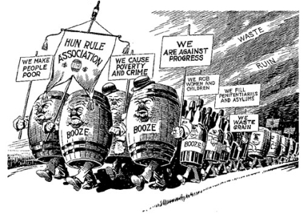 On December 17, 1917, the House of Representatives voted 282 to 128 to approve the 18th Amendment and prohibit the manufacture, transportation and sale of alcoholic beverages in the United States. One day later, by a 47 to 8 vote, the US Senate agreed. During the next year, more than three-quarters of the states ratified, and in early 1920, the 18th Amendment went into effect. The country was now officially **dry**.

Prohibition passed for several reasons. For one thing, it rode the coattails of the Progressive Movement. That is, a number of states decided that drinking was behind some of America’s most serious problems – problems like corruption, child abuse, crime, unemployment, and worker safety. Also, John D. Rockefeller and Henry Ford saw drinking as a huge drag on the economy. Drunken workers and absentee workers were not good for American business. For these reasons, individual states took action. By the time America entered World War I in 1917, twenty-six states had voted themselves dry.

World War I overwhelmed the **wets** as they tried to oppose the push for Prohibition. Many Americans believed that spending money on beer, wine, and whiskey when the nation needed all its resources to fight in Europe was unpatriotic. Others went further. Germany was the main enemy in the war. Wasn’t it true that many of America’s major breweries – Pabst, Blatz, Schlitz, Budweiser – had German names? German-Americans and their breweries were an easy target. Also there were the Jews and their Sabbath wine, and those hard-drinking, slum-dwelling Irishmen, Italians, and Greeks. **Nativists** saw Prohibition as a way to clean up the cities and the people in them.

Once the 18th Amendment passed Congress, it was then necessary to create legislation to carry it out. This took the form of the famous Volstead Act. Among other provisions, the Volstead Act defined a drink as intoxicating if it contained more than 1% alcohol. This made beer and wine illegal, which came as a surprise to many. Workers who supported the Eighteenth Amendment had been assured that it would apply only to hard liquor. When wine and beer were outlawed there was immediate criticism. In fact, President Woodrow Wilson vetoed the Volstead Act because he thought it was too strict. Congress quickly overrode the veto, not wanting to appear soft to their dry supporters.

Beginning in 1922 and continuing for the next ten years, *Literary Digest* magazine con-ducted annual polls to measure how Americans felt about Prohibition. In 1922, nearly 80% were in general support; only about 20% were against Prohibition. Ten years later, those numbers were turned upside-down. In 1932, three out of every four Americans wanted **repeal**.

Congressmen read the polls. In 1933, by a huge majority, both the Senate and the House voted to remove the 18th Amendment. It was the only time in American history that an amend-ment to the Constitution has been repealed.

**Vocabulary**

dry: outlawing alcohol

wet: people wanting to keep alcohol legal

nativist: someone against immigrants

repeal: to cancel or remove

**Document A**

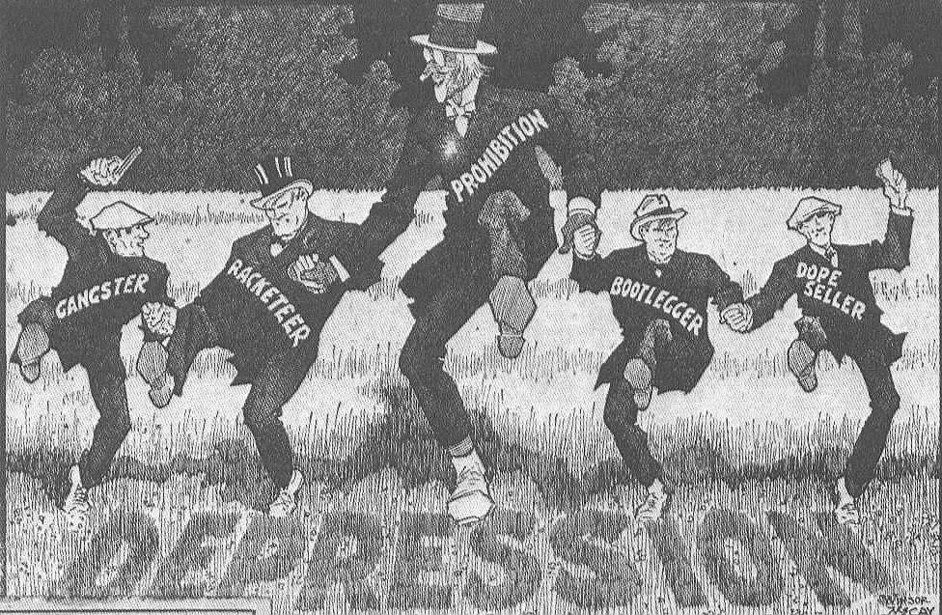

*Source: Winsor McCay, from* Temperance or Prohibition?*, 1929.*

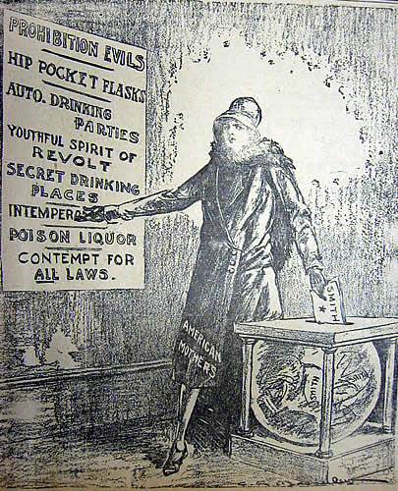

*Source:* Putnam County Courier*, October 12, 1928.*

**Document B**

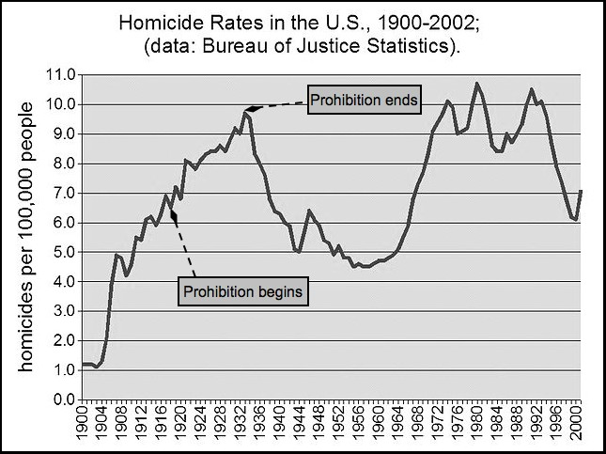

*Source: “FBI Uniform Crime Reports”, in* Drug War Facts, *2008.*

**Document C (modified)**

Obviously there would be no bootleggers if there were no market for their wares. The volume of their business demonstrates the widespread disregard of the law on the part of the American people. Careful investigators have reported that there is scarcely a community in the United States that is entirely free of the liquor traffic, and in the larger cities the evasions and violations of the law are constant rather than sporadic…. Men and women who are otherwise wholly respectable and respected are regular customers of the bootleggers.

The stories of prohibition enforcement are more absorbing than detective tales. The agents of the Government spend their time in a ceaseless contest to outwit and apprehend the illicit distillers, smugglers, and bootleggers who resort to every trick to escape detection and interference with their highly profitable business…. A southern manufacturer of corn liquor marketed his product by delivering it to city retailers in milk cans.

Smuggling from Mexico and Canada has been successful on a large scale because it is impossible to patrol the thousands of miles of border. The liquor brought across the line at the North or at the South finds its way hundreds of miles into the interior of the United States, instances having been found of bootleggers that maintained large fleets of trucks and automobiles running on regular schedules between Mexican and Canadian points and cities such as St. Louis, Kansas City, and Denver.

On the Atlantic Coast the smugglers are so numerous and so active that there is at all times what is known as a rum fleet standing off or anchored outside the 3-mile limit near New York and New Jersey. The fleet consists of vessels of all kinds and sizes that bring their illegal shipments from the Bermudas or the West Indies, or even from across the Atlantic. As long as they remain outside the 3-mile limit this Government can not interfere with them and they are able to make their deliveries to bootleggers that slip out to them under cover of darkness in motor speed boats.

*Source: Frederic J. Haskin,* The American Government, *1923.*

**Vocabulary:**

wares: goods

sporadic: not frequent

bootlegger: seller of illegal liquor

ceaseless: endless

illicit distiller: maker of illegal liquor

fleet: group of ships

**Document D**

[T]he very men who made the Prohibition law are violating it…. How can you have the heart to prosecute a bootlegger, send a man to jail for six months or a year for selling a pint or a quart of whiskey, when you know for a fact that the men who make the laws…are themselves patronizing bootleggers?

I have not lived in Washington all these years without becoming well acquainted with the fact that many Congressmen and Senators…are persistent violators of the Volstead Act. Senators and Congressmen have appeared on the floors [of Congress] in a drunken condition. Bootleggers infest the halls and corridors of Congress and ply their trade there.

*Source: Mabel Walker Willebrandt, Deputy Attorney General for Prohibition Enforcement,* The Inside of Prohibition, *1929.*

**Vocabulary:**

bootlegger: seller of illegal liquor

patronizing: buying products from

persistent: constant

infest: overrun

ply: carry out

**Document E**

Before prosperity can return in this country, the budgets of local and national governments must be balanced. If the liquor now sold by bootleggers was legally sold, regulated and taxed – the income would pay the interest on the entire national debt and leave more than $200,000,000 for…urgently needed purposes.

*Source: Leslie Gordon,* The New Crusade, *1932.*

**Vocabulary:**

prosperity: wealth, economic success

urgently: immediately

Why Did Prohibition Fail? Name____________________________

|  |  |  |
| --- | --- | --- |
|  | What does this document tell us about why Prohibition failed? | Provide TWO image details or text quotes that support your answer |
| **Document A** |  | 1.  2. |
| **Document B** |  | 1.  2. |
| **Document C** |  | 1.  2. |
| **Document D** |  | 1.  2. |
| **Document E** |  | 1.  2. |

Quick Outline tasks for Prohibition paragraph

Write one page that answers the question: Why did America change its mind about Prohibition? Use information from the background essay AND information from at least THREE documents in your response.

***Step 1****: Given the specific details provided in note form, write a topic sentence that generalizes from the details. Make sure to mention both the topic and a keyword from each detail.*

T.S.

______________________________________________________________________

* Prohibition ≠ working / dangerous drinking + selling alcohol (Doc A ‘intemperance’)
* Prohibition 🡪 crime / illegal trade (Doc B homicide or Doc C enforcement)
* If legalize + tax alcohol income / pay national debt (Doc A Depression or Doc E Taxes)

**Step 2**: On separate paper, turn the thesis you wrote and the details listed in note form above into a paragraph answering the question “Why did America change its mind about Prohibition?” **Be sure to Introduce, Cite and Explain any detail taken from a document**.

*Below is an example showing how to turn details noted in the outline into complete sentences:*

Notes

otes

* Prohibition ≠ working / dangerous drinking + selling alcohol (Doc A ‘intemperance’, Doc C = bootleggers / smugglers, Doc D = Congress drinking)

Sentences

otes

|  |  |
| --- | --- |
| **I - Introduce your evidence** | According to a political cartoon published in the Putnam County Courier in 1928, |
| **C - Cite your evidence** | prohibition was having serious negative consequences, including “intemperance, poison liquor, secret drinking places, and disregard for all laws.” (Document B) |
| **E – Explain how your evidence proves your point.** | This cartoon shows growing opposition to Prohibition, which did not seem to be working, since instead, many went to desperate and dangerous measures to keep drinking. |

(Note that “I” and “C” are part of the same sentence.)

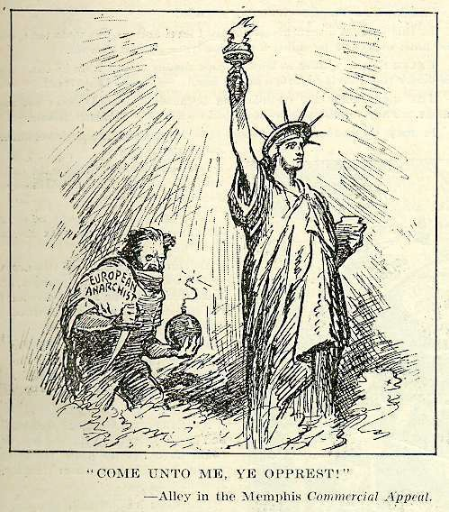**Focus Question** Was the Red Scare of 1919-1920 a dangerous over-reaction or necessary for national protection*?*

***Source:*** *James P. Alley, “Come Unto Me, Ye Opprest!,” originally published in the* Memphis Commercial Appeal*; reprinted in the* Literary Digest*, July 5, 1919.*

**Do Now**: Examine the cartoon carefully and record your observations, thoughts and questions in the chart below.

|  |  |  |
| --- | --- | --- |
| **What do you see?** | **What do you think?** | **What do you wonder?** |
|  |  |  |

**Focus Question**: Was the Red Scare of 1919-1920 a dangerous over-reaction or necessary for national protection?

Context: Before WWI, worker’s organizations and Progressive Era reforms had checked abuses of companies and protected workers. But an anti-immigrant and anti-communist fever hit the country during and after WWI. During the World War I era, the U.S. experienced a “Red Scare,” or national hysteria about the dangers of communists and radicals. The Red Scare was influenced by wartime patriotism, immigration from Eastern Europe, and the Bolshevik communist revolution in Russia, and fueled by newspaper editorials and cartoons.

**Document Set A**

Examine these documents to answer the question: What did the US government fear?

|  |  |  |
| --- | --- | --- |
| **Document Set A** | **Source the document.**  **Who created it?**  **Is it reliable as evidence to answer the Q?** | **Based on this document, what was the U.S. Government afraid of during the Red Scare of 1919-1920?** |
| **Doc A1**  A. Mitchell Palmer, “The Case Against The Reds” |  |  |
| **Doc A2**  Step by Step cartoon |  |  |
| **Doc A3** Photo of bombed home of A. Mitchell Palmer |  |  |
| **Doc A4**: Strike poster in several languages |  |  |

**Document Set B:**

Examine these documents to answer the question: Was the Red Scare a dangerous over-reaction or necessary to the nation’s security?

|  |  |  |
| --- | --- | --- |
| **Document Set B** | **Source the document.**  **Who created it?**  **Is it reliable as evidence to answer the Q?** | **Based on this document, were the US Government’s actions dangerous over-reactions or necessary for the safety of the nation?** |
| **Doc B1**  IWW Office Raid photo |  |  |
| **Doc B 2**  Headlines after Palmer raids |  |  |
| **Doc B3**  Emma Goldman Deportation speech |  |  |

**Vocabulary Activity (before and during reading Documents A and B)**

**Match the vocabulary word to its definition below.**

1. aliens __ a. take over

2. usurp __ b. twist out of shape

3. distort __ c. foreigners

4. vigilance __ d. hope or ambition

5. banished __ e. being watchful and alert, especially to danger

6. aspiration __ f. kicked out

7. menace __ g. a series of legal actions in court (including hearings)

8. proceedings __ h. a disturbance created when a crowd gets out of control and violent

9. riot i. danger/threat

**Vocabulary review**

1. If someone **distorts** your words, they are:
2. Not agreeing with anything you say, and arguing strongly against you.
3. Saying what you said, but in a way that makes it sound different from what you meant .
4. When the document A states that the Department of Justice will pursue communists attacking the US with **vigilance**, it means that
   1. the Department of Justice will be very alert and careful in trying to catch the communists attacking the U.S.
   2. the Department of Justice will try to catch the communists attacking the U.S. as a revenge on Russia.
5. If a person is **banished** from their country:
   1. They have to leave for a long time.
   2. They can never come back
6. The word **proceedings** in the document B means:
7. legal action brought in court against someone
8. an action or course of action
9. published records of a conference
10. Which of the following is an example of a **riot**?
    1. Two kids get into a fight after school, and one of them winds up using a gun.
    2. At a protest against high prices, angry protesters begin setting fire to stores and police cars.

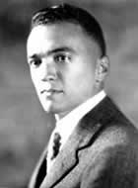**Document A1: “The Case Against the "Reds" (Modified)**

A. Mitchell Palmer (left) US Attorney General. J. Edgar Hoover (right) Palmer’s deputy and head of the Justice Department’s “Radical Division” that carried out the Palmer raids and later 1st Director of the FBI; he directed the agency until 1972.

Like a prairie-fire, the blaze of revolution was sweeping over every American institution a year ago. It was eating its way into the homes of the American workmen, its sharp tongues of revolutionary heat were licking the altars of the churches, leaping into schools, crawling into the sacred corners of American homes, burning up the foundations of society.

My information showed that thousands of aliens supported communism in this country.

The whole purpose of communism appears to be a mass organization of the criminals of the world to overthrow the decencies of private life, to usurp property that they have not earned, to disrupt the present order of life.

The Department of Justice will pursue the attack of these "Reds" upon the Government of the United States with vigilance, and no alien, advocating the overthrow of existing law and order in this country, shall escape arrest and prompt deportation.

*Source: Excerpt from an essay written by A. Mitchell Palmer called "The Case Against the ‘Reds,'” 1920.*

**Vocabulary**

Aliens: Foreigners

Usurp: take over

Document A2

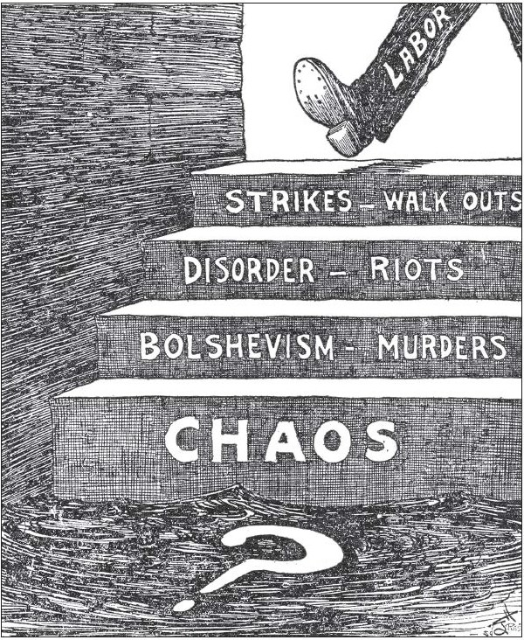

Greene, "Step by Step" *(New York Evening* *Telegram).* Re produced from *The Literary Digest* (1 Nov. 1919), p.12.

**Document A3**

**"Bombing at the Home of Attorney General Palmer"**

*During the spring of 1919, a group of anarchists (known as Galleanists because they were followers of Italian anarchist Luigi Galleani) sent a series of mail bombs to U.S. government officials and judges. On June 2, 1919, one of these bombs exploded at the home of Attorney General A. Mitchell Palmer, and he and his family barely escaped death. Later that year, Palmer launched a series of police actions that became known as the Palmer Raids. Federal agents supported by local police rounded up large groups of suspected radicals, often based on membership in a political group rather than any action taken. Thousands were arrested and hundreds deported.*

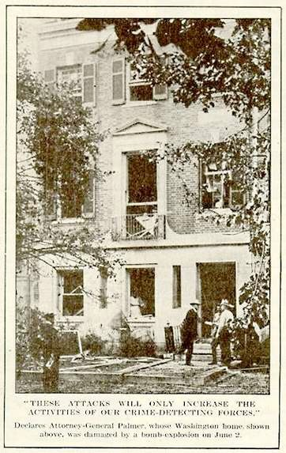

*These attacks will only increase the activities of our crime-detecting forces," declares Attorney-General*

*Palmer, whose Washington home, shown above, was damaged by a bomb-explosion on June 2.*

**Source** | “Bombing at the Home of Attorney General Palmer, *Literary Digest*, June 14, [1919http://newman.baruch.cuny.edu/digital/redscare/HTMLCODE/CHRON/RS003.HTM](http://newman.baruch.cuny.edu/digital/redscare/HTMLCODE/CHRON/RS003.HTM) **Item Type** | Photograph

**Optional Document A4**

**A Steelworkers' Ballot Calls "Strike!" in Many Tongues**

*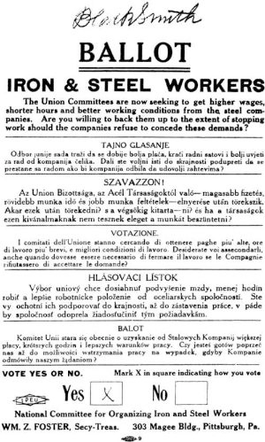In the years after World War I, American workers sought to consolidate and expand the gains they had achieved during the war years. In September 1919, some 350,000 steelworkers went on strike, seeking higher wages, shorter hours and better working conditions. This ballot, printed in English, Croatian, Hungarian, Italian, Slovak, and Polish and distributed by the National Committee for Organizing Iron and Steel Workers, reflects the broad range of nationalities comprising the industry's workforce.*

***Source*** *| William Z. Foster, The Great Steel Strike and Its Lessons (1920) American Social History Project.* ***Item Type*** *| Pamphlet/Petition*

Document Set B: Was the Red Scare a dangerous over-reaction or necessary to the nation’s security?

Document B1

Palmer Raids: U.S. Attorney General (the nation’s top lawyer appointed by President Wilson) sent his agents on simultaneous raids in major cities to break into the homes and meeting places of thousands of suspected revolutionaries. 4,000 people were arrested, mostly non-citizens.. Some were jailed, others deported.

*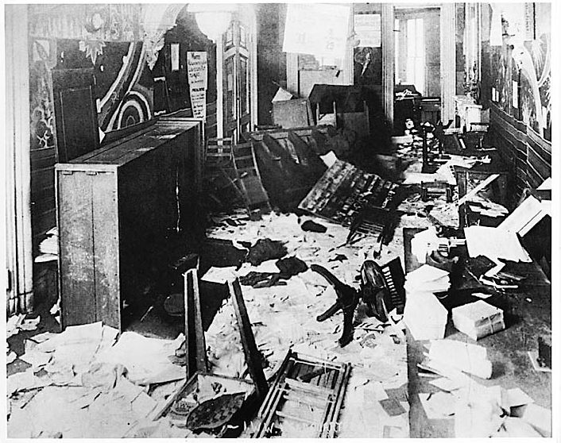International Workers of the World union headquarters, New York City, after the raid of November 15, 1919. Special Collections Library, Labadie Collection, University of Michigan*

Document B2

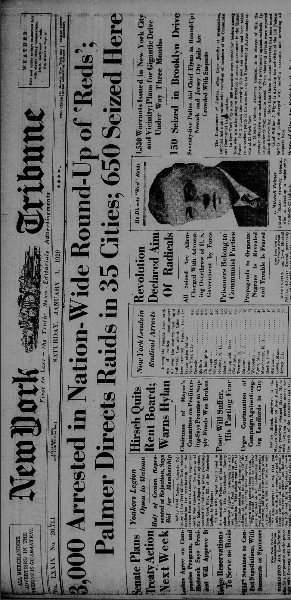

**Source**: Front page of the New York Tribune newspaper from January 3, 1920, "[3,000 Arrested in Nation-Wide round-up of "Reds"](http://chroniclingamerica.loc.gov/lccn/sn83030214/1920-01-03/ed-1/seq-1/;words=Palmer+raid+raids+Raids+Raided?date1=11%2F06%2F1919&date2=11%2F12%2F1922&searchType=advanced&sequence=1&proxdistance=5&rows=20&ortext=&proxtext=&phrasetext=&andtext=palmer+raid&dateFilterType=range&index=3)," New York Tribune (New York, NY), January 03, 1920, Page 1, Image 1, col. 5.

**Document B3: Emma Goldman Deportation Statement (Modified)**

I wish to register my protest against these proceedings, whose very spirit is nothing less than a revival of the ancient days of the Spanish Inquisition or Czarist Russia (when anyone who disagreed with the government was deported or killed). Today so-called aliens are deported. Tomorrow American citizens will be banished. Already some “patriots” are suggesting that some native-born American citizens should be exiled.

The free expression of the hopes of a people is the greatest and only safety in a sane society. The object of the deportations and of the anti-anarchist law is to stifle the voice of the people, to muzzle every aspiration of labor. That is the real and terrible menace of these proceedings. Their goal is to exile and banish every one who does not agree with the lies that our leaders of industry continue to spread.

Emma Goldman

New York, October 27, 1919

*Source: Excerpt from the statement Emma Goldman gave at her deportation hearings. Goldman was an anarchist and socialist who sympathized with the working poor. She was deported during the Palmer Raids.*

**Vocabulary**

Banish = Exile = Deported = Kicked out of the country

Aspiration: hope or ambition

Menace: danger, threat



“The Soviet Ark” a US army transport carrying 249 deported Russian ‘Reds” as America’s Christmas present to Lenin and Trotsky, including Emma Goldman.

Timeline of Key Events of the Red Scare, 1917-1920

***This timeline shows the major events of U.S. involvement in World War I and the anti-radical hysteria, known as the “Red Scare,” that also occurred at this time.***

**1917**

* *April 2*: President Woodrow Wilson asks Congress to approve American entry into World War I against Germany
* *June*: the **Espionage Act** is passed, banning the sending of treasonous (expressing disloyalty to the government) material through the mail; the Post Office uses the Act to shut down socialist publications and others that were critical of U.S. involvement in the war
* *November*: The Bolshevik Revolution brings a communist government to Russia. Vladimir Lenin and his Bolshevik party vow to lead a worldwide anti-capitalist revolution. Lenin pulls Russia out of the war.

**1918**

* *May*: Congress passes the **Sedition Act**, which makes it a crime to use “disloyal, profane, scurrilous, or abusive” language against the government, the Constitution, the flag, and the military uniform. That summer, Socialist Party leader Eugene Debs is sentenced to ten years in prison for delivering a speech against the war and in favor of free speech (He was pardoned and released in 1921.)
* *November 11*: Germany surrenders, ending World War I

**1919**

* A massive wave of strikes agitates the nation. *February 6*: 60,000 workers walk off the job in a four-day “General Strike” in Seattle. There is little or no violence, but Mayor Ole Hanson calls in federal troops to patrol and maintain order.
* *Spring*: In *Schenck v. U.S.*, the U.S. Supreme Court upholds the Espionage Act, ruling unanimously that the First Amendment can be restricted in time of war if speech creates a “clear and present danger.” “Free speech,” writes Justice Oliver Wendell Holmes, “would not protect a man falsely shouting fire in a theater and causing panic.”
* *June 2*: Bombs go off in eight cities, killing two people. One bomb destroys part of Attorney General A. Mitchell Palmer’s home in Washington, D.C. Soon after, Palmer strengthens the Justice Department’s “Bureau of Investigation” (forerunner to the F.B.I.) by creating a new “anti-radical” unit called the General Intelligence Division. The new division is headed by a young man named J. Edgar Hoover.
* *September*: Boston policemen go on strike, leading to rioting and looting. Massachusetts Governor Calvin Coolidge calls out National Guard to restore order and fires the entire police force. Meanwhile, more than 300,000 steel workers go on a nationwide strike. Coal miners also threaten to strike; mine owners claim the strike is being ordered and financed by Soviet Russia.
* *October*: The U.S. Senate discovers that most of the 54 alien radicals arrested during the Seattle general strike have not been deported. The Senate demands that Attorney General Palmer explain why not.
* *December*: Attorney General Palmer and the U.S. Justice Department deport 249 so-called ‘illegal aliens’ to the Soviet Union aboard the Army transport ship Buford, nicknamed the “Soviet Ark.”

**1920**

* *January 2*: Directed by Attorney General Palmer and using information gathered by J. Edgar Hoover, federal agents break into the homes and meeting places of thousands of suspected revolutionaries in thirty-three cities. The agents, expecting to find evidence that radicals were arming for revolution, uncover a few pistols and no explosives. Still, they arrest 4,000 people, mostly non-citizens in what became known as the Palmer Raids.
* *January*: The steel strike collapses.
* *May*: Palmer’s prediction of a May Day radical uprising fails to come true; public approval for his methods declines.
* *September*: A bomb explodes on Wall Street, killing thirty and injuring over 300; most see it as the work of a lone fanatic rather than a large conspiracy.

**April 6, 1917**: The U.S.A enters World War I by declaring war on Germany

**October 1917**: The Bolshevik Revolutoin brings a Communist government to power in Russia.

**Mary 1918**: The U.S./ Congress passes the Sedition Act (and amendment ot the Espionage Act of 1917)

**November 1918**: Germany signs the Armistice ending World War I.

**Summer 1919**: A series of bombs is mailed to prominent Americans.

**1919-1920:** A massive wave of strikes agitates the nation.

**November 1919 – January 1920:** Attorney General A. Mitchell Palmer and his special assistant J. Edgar Hoover direct the largest mass arrests in U.S. history. The “Palmer Raids” result in the incarceration of thousands of suspected “subversives.”

**May 1 (May Day) 1920:** The communist uprising predicted by Attorney General Palmer fails to occur. Later, he is accused of helping to create a climate of fear for political advantage.

Simplified timeline

**Vocabulary Activity**

**Match each of the following words to their definitions:**

1. communists ___ a. insulting; abusive

2. scurrilous ___ b. a law that made it illegal to criticize the U.S. government

3. Sedition Act ___ c. when a group of people plot together – often against a leader or government

4. conspiracy ___ d. people who want a classless (entirely equal) society

5. anarchist ___ e. to include or contain

6. Bolshevik Revolution___ f. an extremely strong dislike

7. aversion ___ g. a person who believes in the abolition of government as we know it

8. comprise ___ h. Communist Revolution in Russia in 1917

9. Which of the following is a **conspiracy**?

a) a secret plan by a group of people to do something, usually illegal

b) a secret plan by an individual to do something, usually illegal

10. The **Bolshevik Revolution** was started by**:**

a) anarchists

b) communists

Writing Activity

Instructions: Using evidence from 3 or more of the documents examined today, write a well-developed paragraph in which you respond to the focus question, *Was the Red Scare of 1919-1920 a dangerous over-reaction or necessary for the national protection?*

Use this quick outline to draft your topic sentence and plan your paragraph.

T.S. _______________________________________________________________________________________________________________________.

1. ……………………………………………………………………………………………………
2. ……………………………………………………………………………………………………
3. ……………………………………………………………………………………………………
4. ………………………………………………………………………………………………………

C.S. _______________________________________________________________________

*Directions: Read Section 3 of the Sedition Act (1918) below and answer the questions that follow:*

Whoever, when the United States is at war, shall willfully make or convey false reports of false statements with intent to interfere with the operation or success of the military or naval forces of the United States, or to promote the success of its enemies…or incite insubordination, disloyalty, mutiny, or refusal of duty, in the military or naval forces of the United States, or shall willfully obstruct… the recruiting or enlistment service of the United States, or…shall willfully utter, print, write or publish any disloyal, profane, scurrilous, or abusive language about the form of government of the United States, or the Constitution of the United States, or the military or naval forces of the United States… or shall willfully display the flag of any foreign enemy, or shall willfully…urge, incite, or advocate any curtailment of production… or advocate, teach, defend or suggest the doing of any of the acts of things in this section enumerated and whoever shall by word or act support or favor the cause of any country with which the United States is at war or by word or act oppose the cause of the United States therein, shall be punished by a fine of not more than $10,000 or imprisonment for not more than twenty years, or both.

1. List at least 3 activities that this section of the Sedition Act made illegal (in your own words).
2. Can you think of any situations where a person might do one or more of these things without being a traitor to the United States?

Focus Question: How and why did the U.S. government bring the peak era of immigration to the U.S. to an end in the 1920s?

**Do Now**: Read the following quote, explain it in simple terms and then state whether you agree or disagree with the author’s analysis of the Trump election and why.

“Throughout our history, a substantial minority of whites has responded to America’s always-shifting racial and economic terrain with a primal fear of being dominated, of finding themselves at the bottom of the hierarchy. It’s one of the strongest forces in American life, and politicians and demagogues of many partisan stripes channeled it long before Donald Trump.” --Jamelle Bouie, “*The Racist backlash against Obama is what brought us Donald Trump*,” *Slate,* March 13, 2016

Backlash: a reaction to social change in which people push back against the change.

**CONVERSATION ROUNDTABLE 1: How did the U.S. Government put an end to ‘open’ immigration in the 1920s? (Documents A - C)**

1. My notes 2. What said

5. Our group's agreed on response

1. What said
2. What said

**CONVERSATION ROUNDTABLE 2: Why did the U.S. Government put an end to ‘open’ immigration in the 1920s? (Documents D - G)**

1. My notes 2. What said

5. Our group's agreed on response

1. What said 4. What _________said

Document A “The Only Way to Handle It”

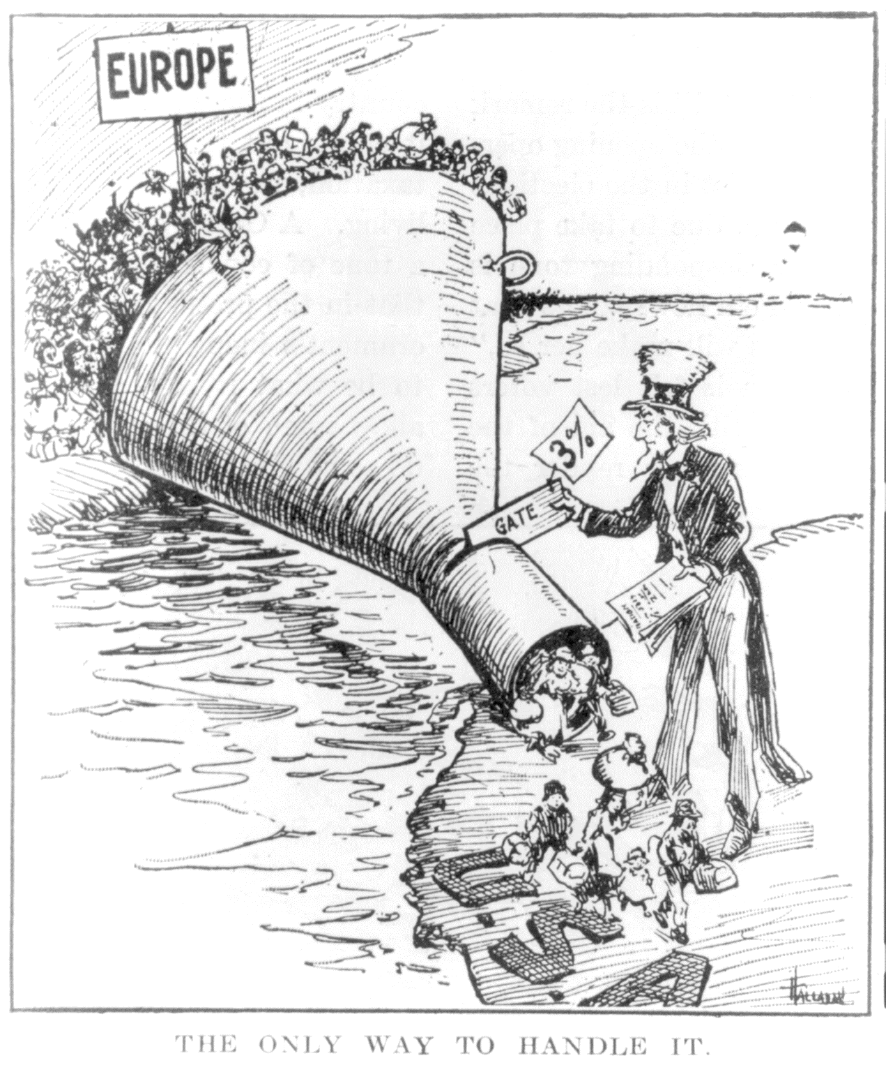

Source: Editorial cartoon by ‘Hallahan’ accompanying an article “an alien anti-dumping bill,” in the Providence Evening Bulletin, reprinted in The Literary Digest, May 7, 1921, p. 13. <http://hdl.loc.gov/loc.pnp/cph.3a44285>

Document B: Effects of immigration Quota Laws

Average Annual Number of Immigrants to the U.S. Before & After Quota Laws

|  |  |  |
| --- | --- | --- |
| Immigration Laws | From Northern and Western Europe | From Southern and Eastern Europe and Asia |
| Before Quotas (1907-1914) | 176,983 | 685,531 |
| During Emergency Quota Act of 1921 | 198,082 | 158,367 |
| During Emergency Quota Act as Amended 1924 | 140,999 | 21,847 |
| During National Origins Act of 1929 | 132,323 | 20,251 |

Source: Historical Statistics of the United States, included in NY State U.S. History and Government Regents Exam.

Document C: Secondary source on Immigration Quota Laws

Immigration to the United States began to rebound following the conclusion of World War I. Among those leading the resurgence were refugees from the Russian Revolution, the Armenian genocide, and the collapse of the Italian economy. . . .

The Emergency Quota Act of 1921 established the nation’s first numerical limits on the number of immigrants who could enter the United States, set at 3% of the population of immigrants in the U.S. from each country. The Immigration Act of 1924, also known as the National Origins Act, made the country-by-country quota limits stricter and permanent. …. The final quota figures were based on the ratio (relative amounts, or percentages) of different ethnic groups existing in America in 1890, before the second big wave of immigration by southern and eastern Europeans.

# Source: Adapted from a secondary source summarizing the end of open immigration. National Park Service: Ellis Island National Monument, “Closing the Door on Immigration.” https://www.nps.gov/articles/closing-the-door-on-immigration.htm

Quota = a limit set on the number of people or things allowed (in this case, a maximum number of immigrants per country)

**Document D: “Close the Gate” political cartoon**

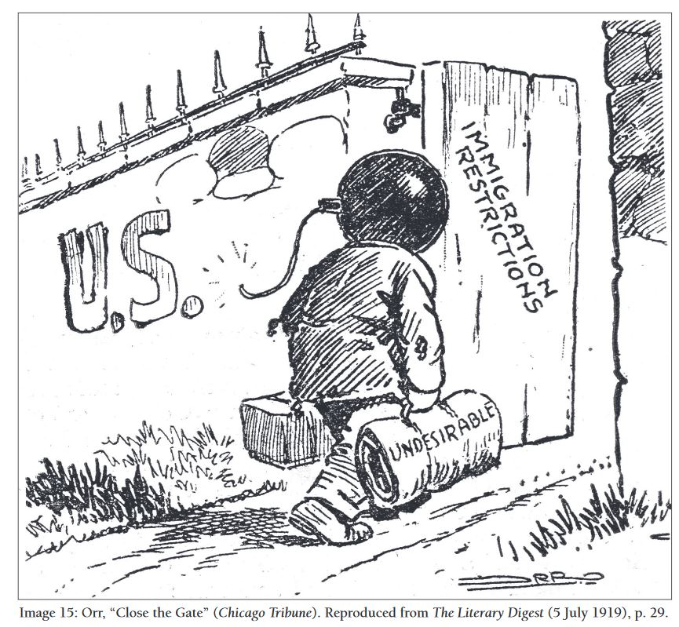

Source: Editorial Cartoon by Orr, “*Close the Gate*.” Originally published in the *Chicago Tribune*, republished in *The Literary Digest* July 5, 1919.

Document E: The Pseudoscience of Eugenics

**Introductory note:** Starting in the 1890s, professors from Harvard University and other prestigious American institutions embraced the pseudoscience (fake science) of Eugenics. They believed in the superiority of a northern and western European “Nordic race” and thought their ideas were an extension of Darwin’s theory of the survival of the fittest. They conducted studies, now known to be faulty, that showed non “Nordic” people to be more prone to criminality, low intelligence and to be a burden on society. Even though they looked backwards to an idealized America and held racist ideas, they counted themselves as modern scientists and Progressives attempting to perfect the American people through science.

While not every American lawmaker agreed that peoples’ potential was determined by their ethnic origins, the two Congressional commissions that studied the issue provided Nativists with eugenic arguments and other evidence they used to pass these laws by a large margin.

The matter of social and cultural assimilation of immigrants has just come to an acute (crisis) state in the United States. The formation of isolated alien (foreign) centers, which maintain their alien languages and cultures, is a dangerous thing for the American people. . . .

If the American Nation decides that it is still unmade as a people, then it might as well throw open the doors and admit all comers, but if it decides that we have national ideals worth saving, not only in national tradition and individual quality, but also racial ingredients, the Nation must exercise stricter control over immigration. This is a critical period in American history. We can continue to be American, to recruit to and develop our racial qualities, or we can allow ourselves to be supplanted by other racial stocks.

Source: Testimony to the US Congress House Committee on Immigration by Dr. Harry H. Laughlin on March 8, 1924. Laughlin was selected by the House Committee chairman as the “Expert Eugenics Agent” for the Committee on Immigration and Naturalization of the House of Representatives in 1921.

Document F: Labor competition

If you want to protect these men, protect them by keeping out those who work for starvation wages and spread their dangerous doctrines (ideas) around the industrial establishments (factories) of our country, and take the places of our men, and get money that ought to be going into the pockets of the loyal wage earners of America.

…. You are permitting people to come over here who never become citizens of this country. They go into our industrial establishments and take the places that should be filled by American workingmen. They get the places and American workingmen are walking the streets idle and hungry. Senators, the time has come to stop this thing. We are seeking to keep these people out.

Source: Democratic Senator from Alabama, Thomas J. Heflin made this argument in favor of restricting immigration in a debate in the U.S. Senate that took place on *May 2, 1921.*

Documents G(1&2): The Second Klan

**Introductory note:** Founded in 1866 as a secret, violent vigilante anti-black organization, the Ku Klux Klan was outlawed in 1871, but was reborn in the 1920s. The second Klan broadened its message of hate to include Catholics, Jews and foreigners. Their message struck a chord, and membership in the Klan ballooned in the 1920s. By the middle of the decade, estimates for national membership in this secret organization ranged from three million to as high as eight million Klansmen. Nineteen twenties membership included doctors, lawyers and ministers as loyal supporters of the KKK. In Ohio alone their ranks surged to 300,000. Even northeastern states were not immune. In Pennsylvania, membership reached 200,000. The Klan remained a clandestine (secret) society, but it was by no means isolated or marginalized. In the 1920s, the Klan moved in many states to dominate local and state politics. (adapted from PBS The American Experience)

Document G1

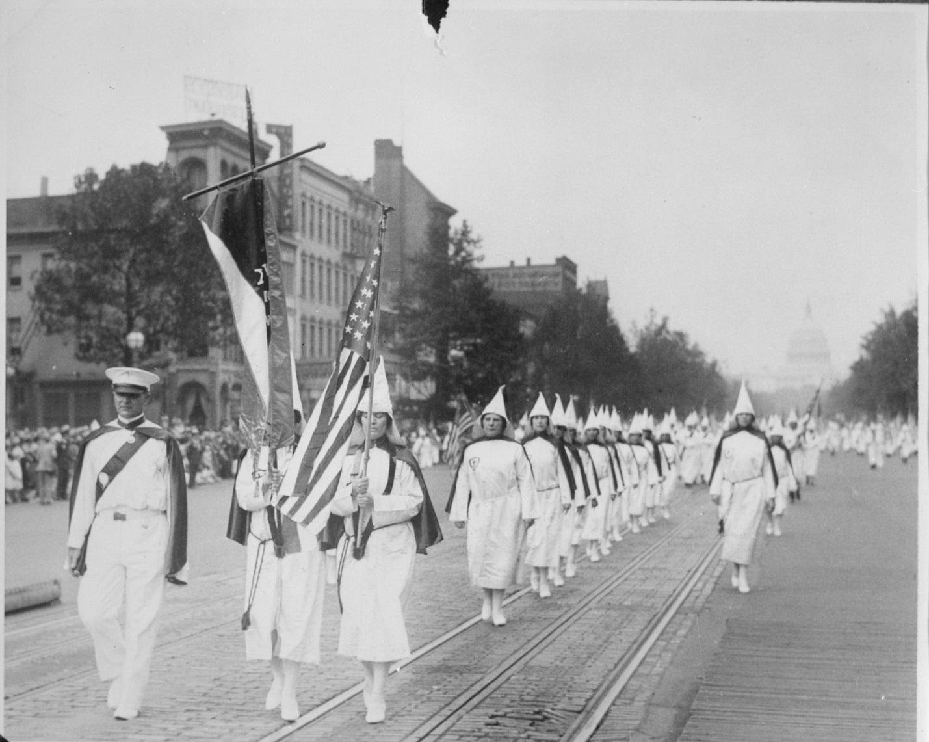

Source: The Ku Klux Klan on parade down Pennsylvania Avenue [Washington, D.C.]; 1928; Records of the U.S. Information Agency, Record Group 306. National Archives Identifier: [541885](https://catalog.archives.gov/id/541885)

Document G2

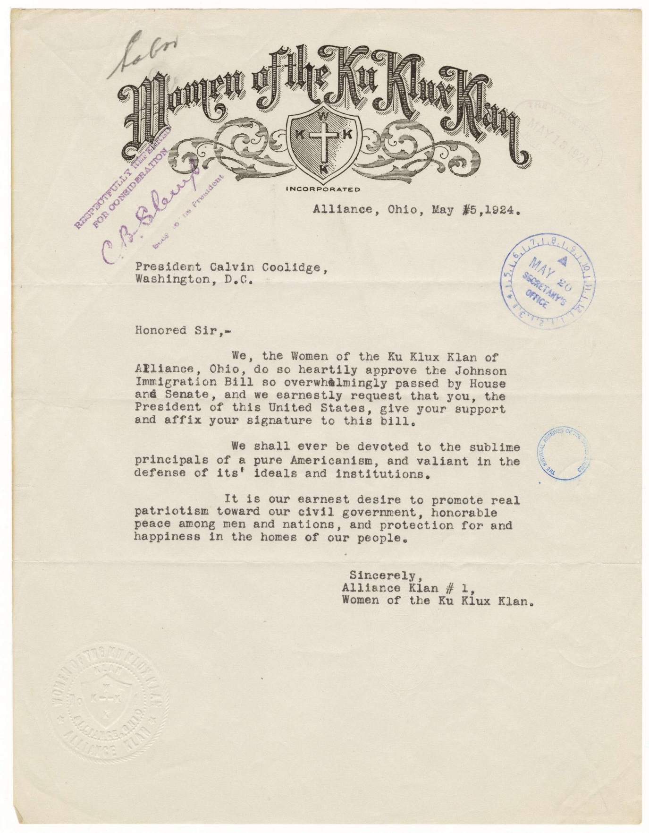

Source: Letter from Women of the Ku Klux Klan to President Calvin Coolidge; May 15, 1924;

National Archives Identifier: [7455592](https://catalog.archives.gov/id/7455592)

The New Era: Culture War ***HW Reading Unit 7 Lesson 5***

From *The American Yawp*: <http://www.americanyawp.com/text/22-the-twenties/>

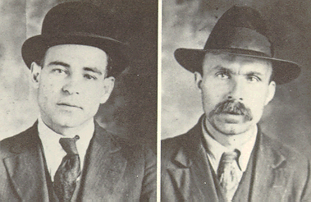For all of its cultural ferment (change), the 1920s were also a difficult time for radicals and immigrants and anything “modern.” Fear of foreign radicals led to the executions of Nicola Sacco and Bartolomeo Vanzetti, two Italian anarchists, in 1927. In May 1920, the two had been arrested for robbery and murder connected with an incident at a Massachusetts factory. Their guilty verdicts were appealed for years as the evidence surrounding their convictions was slim. Nevertheless, despite worldwide lobbying by radicals and a respectable movement among middle-class Italian organizations in the United States, the two men were executed on August 23, 1927. Vanzetti conceivably provided the most succinct reason for his death, saying, “This is what I say . . . . I am suffering because I am a radical and indeed I am a radical; I have suffered because I was an Italian, and indeed I am an Italian.”

Nicola Sacco and Bartolomeo Vanzetti were executed by electric chair on August 23, 1927. Mug shots from Police Department [Public domain], via Wikimedia Commons

Many Americans expressed anxieties about the changes that had remade the United States and, seeking scapegoats (people to blame), many middle-class white Americans pointed to Eastern European and Latin American immigrants (Asian immigration had already been almost completely prohibited), and African Americans who now pushed harder for civil rights after migrating out of the American South to northern cities as a part of the Great Migration, the mass exodus that carried nearly half a million blacks out of the South between 1910 and 1920. Protestants, meanwhile, continued to denounce the Roman Catholic Church and charged that American Catholics gave their allegiance to the pope and not to their country.

In 1921, Congress passed the Emergency Immigration Act as a stopgap (temporary) immigration measure and then, three years later, permanently established country-of-origin quotas through the National Origins Act. The number of immigrants annually admitted to the United States from each nation was restricted to 2 percent of the population who had come from that country and resided in the United States in 1890. (By pushing back three decades, past the recent waves of “new” immigrants from southern and Eastern Europe, Latin America, and Asia, the law made it extremely difficult for immigrants outside northern Europe to legally enter the United States.) The act also explicitly excluded all Asians, although, to satisfy southern and western growers, it temporarily omitted restrictions on Mexican immigrants. The Sacco and Vanzetti trial and sweeping immigration restrictions pointed to a rampant nativism. A great number of Americans worried about a burgeoning (expanding) America that did not resemble the one of times past. Many wrote of an American riven (torn apart) by a cultural war.

**CONVERSATION ROUNDTABLE PROTOCOL RUBRIC**

|  |  |  |  |  |
| --- | --- | --- | --- | --- |
|  | **Level 4**  **Exceeded** | **Level 3**  **Mastered** | **Level 2**  **Approaching** | **Level 1**  **Below** |
| **Cite strong and thorough textual evidence** | Includes relevant evidence from sources to support analysis as well as inferences | Includes textual evidence from sources to support analysis as well as inferences | Includes little textual evidence to support analysis of what the text says explicitly as well as inferences drawn from the text, | Includes no textual evidence to support analysis of what the text says explicitly as well as inferences drawn from the text |
| **Come to discussions prepared** | Spends time preparing for discussion by individually writing a thorough response | Uses time wisely in class to prepare for discussion by individually writing response | Is mostly prepared for the discussion, but didn’t individually write a clear response | Has done little to no preparation for the discussion with no written response |
| **Work with peers democratically** | Roles are established; work is done efficiently | All members work together, although it may not be the most efficient or equal | An attempt to establish roles or divide up the work, however, it is not followed through | One person does all the work OR there is no agreement about how the work should be completed |
| **Propel conversation & promote creative thinking** | Students ask thoughtful and probing questions of one another and the conversation remains engaging | Students respond to one another to keep the conversation going | Students attempt to respond to one another to keep the conversation going | The conversation ends abruptly and no one tries to keep it going |
| **Respond thoughtfully & synthesize comments** | All students respond to the question insightfully and the synthesis is a perfect summing up of all points raised | All students respond to question and the synthesis mostly sums up all points raised | Some/most of the students respond to the question and there is an attempt at synthesis | Disrespectful comments and off-task conversation |

|  |  |  |  |  |  |  |
| --- | --- | --- | --- | --- | --- | --- |
| **Group Member Name** | **Cite strong and thorough textual evidence** | **Come to discussions prepared** | **Work with peers democratically** | **Propel conversation & promote creative thinking** | **Respond thoughtfully & synthesize comments** | **POINTS EARNED** |
| **1.** | **4   3 2   1** | **4   3 2   1** | **4   3 2   1** | **4   3 2   1** | **4   3 2   1** |  |
| **2.** | **4   3 2   1** | **4   3 2   1** | **4   3 2   1** | **4   3 2   1** | **4   3 2   1** |  |
| **3.** | **4   3 2   1** | **4   3 2   1** | **4   3 2   1** | **4   3 2   1** | **4   3 2   1** |  |
| **4..** | **4   3 2   1** | **4   3 2   1** | **4   3 2   1** | **4   3 2   1** | **4   3 2   1** |  |
| **Comments** | | | | | | |

**Document A: Textbook**

In the summer of 1919, over 20 race riots broke out across the nation. The worst violence occurred in Chicago. On a hot July day, African Americans went to a whites-only beach. Both sides began throwing stones at each other. Whites also threw stones at an African American teenager swimming near the beach to prevent him from coming ashore, and he drowned. A full-scale riot then erupted in the city. Angry African Americans attacked white neighborhoods while whites attacked African American neighborhoods. The riots lasted for several days. In the end, 38 people died—15 white and 23 black—and over 500 were injured.

*Source: The American Vision*, 2006, p. 393.

**Document B: History Book (Modified)**

The most serious racial outbreak occurred in Chicago late in July of the so-called Red Summer…. The riot that began on July 27 had its immediate origin in a fight at Lake Michigan beach. A young Negro swimming offshore had drifted into water that was customarily used by whites. White swimmers commanded him to return to his part of the beach, and some threw stones at him. When the young man drowned, the Negroes declared that he had been murdered.... Rumors spread among blacks and whites. Mobs sprang up in various parts of the city. In the next afternoon, white bystanders bothered some blacks who were returning from work. Some were pulled off streetcars and whipped.... On the Negro South Side a group of young Negroes stabbed an old Italian peddler to death, and a white laundry operator was also stabbed to death.... When authorities counted the casualties, 38 people had been killed, including 15 whites and 23 blacks. Of the 537 people injured, 342 were black. More than 1,000 families, mostly Negroes, were homeless due to the burnings and destruction of property.

*Source: John Hope Franklin,* From Slavery to Freedom: A History of Negro Americans*, 1987 (Sixth Edition; first published in 1947). Franklin was a United States historian and past president of the Organization of American Historians and the American Historical Association. More than three million copies of* From Slavery to Freedom *have been sold. In 1995, Franklin was awarded the Presidential Medal of Freedom, the nation's highest civilian honor.*

**Document C (Modified)**

Since 1915 the colored population of Chicago has more than doubled, increasing in four years from a little over 50,000 to what is now estimated to be between 125,000 and 150,000. Most blacks lived in the area called the “Black Belt.” Already overcrowded, this so-called “Black Belt” could not possibly hold the doubled colored population. One cannot put ten gallons of water in a five-gallon pail.

Whites who are afraid that blacks will move out of the “Black Belt” and into “white” neighborhoods have formed the “Property Owners' Association” to keep blacks out of white neighborhoods. They discuss ways to keep Negroes in “their part of town.”

In a number of cases during the period from January 1918 to August 1919, there were bombings of colored homes and houses occupied by Negroes outside of the “Black Belt.” During this period no less than twenty bombings took place, yet only two persons have been arrested and neither of the two has been convicted.

*Source: The document above was published in an African-American newspaper in 1919. Its author was a leader of the NAACP, an organization devoted to protecting African American rights.*

**Document D (Modified)**

The spirit of the Negro who went across the seas -- who was in battle -- is different from the spirit of the Negro before the war. He is altogether a new man, with new ideas, new hopes, new dreams, and new desires. He will not quietly accept discrimination, and we should not ask him to do so. It is a new Negro that we have with us now…. The war transformed these men into new creatures -- citizens of another type.

*Source: The article above was published on August 16, 1919 in* The Independent*, a New York magazine. The author is writing about black soldiers who served in World War One in Europe. More than 350,000 African Americans served in World War One, which ended in 1919. The author, W.S. Scarborough (1852-1926), was an African American author, educator, and lecturer. He was born a slave but eventually became a professor of Latin and Greek, and later president, at Wilberforce University. He wrote frequently about civil rights issues.*

**Document E (Modified)**

*Many people in Chicago worked at meat-packing factories, where they prepared meat to be shipped around the country. These factories were also called “stockyards.”*

**Packers’ Force Cut by 15,000**

*Chicago Daily Tribune,* April 12, 1919

Outsiders who are thinking of coming to Chicago to take a “job at the yards” will not find the “welcome” sign out awaiting them.

It became known yesterday that since the end of the Great War the force of workers has dropped by nearly 15,000. This is due both to a big drop in war orders….

Another problem is that the factories promised to return every employee who enlisted in the armed forces to “as good or better” a job than he held when he put on a uniform. [White] men are now returning in increasingly large numbers and none are being turned away.

“No discrimination is being shown in the reducing of our forces,” said an official of one of the packing companies, in discussing reports that southern colored men, who were hired during the war job shortage, were being fired. “It is a case of survival of the fittest, the best man staying on the job. It is a fact that the southern Negro cannot compete with the northerner.”

*Source: The article above is from the* Chicago Tribune*, the main newspaper in Chicago, April 12, 1919.*

What Caused the Chicago Race Riots of 1919?

*Read Documents A and B and complete the chart below.*

|  |  |
| --- | --- |
| **Similarities** | **Differences** |
|  |  |
| *Which account do you trust more—the textbook or the history book? Explain your answer below.* | |

(Optional) What Caused the Chicago Race Riots of 1919?

|  |  |  |  |
| --- | --- | --- | --- |
| Document | Date / Author | According to this document, what caused the Chicago Race Riots of 1919? | Provide evidence from the document that supports these reasons. |
| **Document C** |  |  |  |
| **Document D** |  |  |  |
| **Document E** |  |  |  |

What Caused the Chicago Race Riots of 1919?

*Complete the outline below by writing a thesis statement that includes your answer to the question above as well as a summary of the causes you will discuss. Record, in note form, the causes of the riots and the evidence from documents that supports them below.*

**Thesis Statement:** __________________________________________________________________________________________________________________________________________________________________________________________________________________________________________

|  |  |
| --- | --- |
| Introduction | General …………………………………………………………………………………  Specific ………………………………………………………………………………..  Thesis Statement ………………………………………………………………… |
| 1st Cause of Riot  ……………………………………………….  ……………………………………………….  ……………………………………………….  ……………………………………………….  Topic Statement | * (evidence)………………………………………………………………………………………….. * (more evidence - optional)…………………………………………………………………… |
| 2nd Cause of Riot  ……………………………………………….  ……………………………………………….  ……………………………………………….  ……………………………………………….  Topic Statement | * (evidence)………………………………………………………………………………………….. * (more evidence - optional)…………………………………………………………………… |
| 3rd Cause of Riot  ……………………………………………….  ……………………………………………….  ……………………………………………….  ……………………………………………….  Topic Statement | * (evidence)………………………………………………………………………………………….. * (more evidence - optional)…………………………………………………………………… |
| Conclusion | Reworded Thesis …………………………………………………………………………  Rephrased specific ……………………………………………………………………  New General statement …………………………………………………………. |

Vocabulary activity for ‘Up South: Great Migration Viewer’s Guide’ pages 2-7

*Match the word in bold on the left with its best definition on the right.*

|  |  |
| --- | --- |
| 1. decline ____ | 1. get weaker |
| 1. **lag** behind ____ | 1. destroy, damage severely |
| 1. devastate ____ | 1. go or develop more slowly so as to fall back |
|  |  |
| 1. plunge ____ | 1. try hard, struggle |
| 1. laws **bar** someone from something____ | 1. rush/fall into |
| 1. strive ____ | 1. a person related to one who lived in the past |
| 1. descendant ____ | 1. prohibit, restrict, forbid |
|  |  |
| 1. caste ____ | 1. disturb, upset |
| 1. dispersed ____ | 1. class |
| 1. **unsettle** someone ____ | 1. scattered |
|  |  |
| 1. **enshrined** in law ____ | 1. apartment buildings with small and poor quality apartment units |
| 1. deteriorating ____ | 1. preserved, protected |
| 1. tenements ____ | 1. worsening, declining |

“How It Feels To Be Colored Me” by Zora Neale Hurston

From a 1928 essay in *The World Tomorrow*

BUT I AM NOT tragically colored. There is no great sorrow dammed up in my soul, nor lurking behind my eyes. I do not mind at all. I do not belong to the sobbing school of Negrohood who hold that nature somehow has given them a lowdown dirty deal and whose feelings are all hurt about it. Even in the helter-skelter skirmish that is my life, I have seen that the world is to the strong regardless of a little pigmentation more or less. No, I do not weep at the world – I am too busy sharpening my oyster knife.

Someone is always at my elbow reminding me that I am the granddaughter of slaves. It fails to register depression with me. Slavery is sixty years in the past. The operation was successful and the patient is doing well, thank you. The terrible struggle that made me an American out of a potential slave said “On the line!” The Reconstruction said “Get set!” And the generation before said “Go!” I am off to a flying start and I must not halt in the stretch to look behind and weep. Slavery is the price I paid for civilization, and the choice was not with me. It is a bully adventure and worth all that I have paid through my ancestors for it. No one on earth ever had a greater chance for glory. The world to be won and nothing to be lost. It is thrilling to think – to know that for any act of mine, I shall get twice as much praise or twice as much blame. It is quite exciting to hold the center of the national stage, with the spectators not knowing whether to laugh or to weep.

The position of my white neighbor is much more difficult. No brown specter pulls up a chair beside me when I sit down to eat. No dark ghost thrusts its leg against mine in bed. The game of keeping what one has is never so exciting as the game of getting.

I do not always feel colored…. I feel most colored when I am thrown against a sharp white background.

**Vocabulary activity: complete before and during reading**

Match the vocabulary words below to their definitions:

1. dammed ___ a. very disorganized and confused

2. lurking ___ b. a small battle

3. helter-skelter___ c. hiding in a scary or creepy way

4. skirmish ___ d. held inside

Harlem Renaissance Quotes

1. I was in love with Harlem before I got there. *– Langston Hughes*
2. Man, we strolled [walked slowly] in Harlem.This was our turf [territory]. *– Elton Fox*
3. Negro stock is going up and everybody’s buying. *– Rudolph Fisher*
4. I, too, sing America.

I am the darker brother.

They send me to eat in the kitchen

When company comes,

But I laugh,

And eat well,

And grow strong. *- Langston Hughes*

1. Color-consciousness [awareness] was the basis of my restlessness. *– Claude MacKay*
2. Negroes in America feel they must always exhibit specimens [show examples] from the college rather than from the kindergarten, specimens from the parlor rather than from the pantry. *– Wallace Thurman*
3. When it comes to pep [energy], pulchritude [beauty], punch and presentation, the Harlem places have Broadway’s nightclubs distanced. *– The Daily News*
4. I would rather have a kitchenette [small apartment] in Harlem than a mansion in Westchester [suburbs of New York City]. *– Langston Hughes*
5. Harlem isn’t typical –but it is significant, it is prophetic [telling of the future]. *– Alain Locke*
6. In America, it is much less dangerous to be a Communist than to be a Negro. *– Claude McKay*
7. Why should I want to be white? I am a Negro – and beautiful. *– Langston Hughes*
8. I’d rather be a lamp post in Harlem than Governor of Georgia. *– folk saying*
9. Subtly [slowly], the conditions that are molding [shaping] a New Negro are molding a new American attitude. *– Alain Locke*
10. The Harlem Renaissance movement of the antic [crazy] nineteen twenties was really inspired and kept alive by the interest and presence of white bohemians [art lovers] *– Claude McKay*
11. We dedicate this tower to…. young Negro writers, sculptors, painters, music artists, composers, and their friends…. A rendez-vous [meeting place] where they may feel at home …amid pleasant, interesting atmosphere. Members only and those who they wish to bring will be accepted. *– Invitation to the opening of the Dark Tower café in Harlem*

The Harlem Renaissance Name__________________________

|  |  |  |
| --- | --- | --- |
|  | Paraphrase the quotation  (rewrite it in your own words) | What theme(s) of the Harlem Renaissance does this quotation express? |
| Quotation # ____ |  |  |
| Quotation # ____ |  |  |
| Quotation # ____ |  |  |
|  | What is going on in the painting?  (describe it in your own words) | What theme(s) of the Harlem Renaissance does this painting express? |
| “Jammin’ At  The Savoy” |  |  |
| “The Migration of The Negro” (1) |  |  |
| “The Migration of The Negro” (58) |  |  |
| “Midsummer Night In Harlem” |  |  |
| “The Janitor  Who Paints” |  |  |

**Up South viewers guide HW reading activities**

Before and during reading: Match the words below to their best definitions:

1. resentment __ a. the period from 1865-1877 (after the Civil War) when the U.S. federal government controlled the states that seceded in Civil War

2. pit one against another __ b. ill feelings

3. Reconstruction __ c. getting people to fight against each other

4. restraint __ d. importance and visibility

5. hucksters __ f. holding oneself back, controlling one’s own behavior

6. prominence __ h. con-men; people who will find a way to trick you out of your money

NOTETAKING: Gist and Talk Back

*For each section, write at least* ***one ‘gist’ note*** *that* ***summarizes*** *events, and* ***one ‘talk back’ note*** *that* ***analyzes*** *events with a comment or question about that section.*

“Conflict and Change in the North”

|  |  |
| --- | --- |
| Gist (what happened) | Talk back (so what / what is the significance?) |
|  |  |

The ‘New Negro’

|  |  |
| --- | --- |
| Gist (what happened) | Talk back (so what / what is the significance?) |
|  |  |

Visualizing African-American Life

|  |  |
| --- | --- |
| Gist (what happened) | Talk back (so what / what is the significance?) |
|  |  |

Look at the chart entitled ‘Asking Questions About the Past’. Did any of your talk back questions or comments match one of the five categories described there and listed below? If so, check which categories of question or comment you included below.

Cause and Effect Turning Points Using the Past Change and Continuity Through Their Eyes

The Negro Speaks Of Rivers by Langston Hughes, 1921

I've known rivers:

I've known rivers ancient as the world and older than the

flow of human blood in human veins.

My soul has grown deep like the rivers.

I bathed in the Euphrates when dawns were young.

I built my hut near the Congo and it lulled me to sleep.

I looked upon the Nile and raised the pyramids above it.

I heard the singing of the Mississippi when Abe Lincoln

went down to New Orleans, and I've seen its muddy

bosom turn all golden in the sunset.

I've known rivers:

Ancient, dusky rivers.

My soul has grown deep like the rivers.

If We Must Die by Claude McKay, 1919

If we must die, let it not be like hogs  
Hunted and penned in an inglorious spot,  
While round us bark the mad and hungry dogs,  
Making their mock at our accursed lot.  
If we must die, O let us nobly die,  
So that our precious blood may not be shed  
In vain; then even the monsters we defy  
Shall be constrained to honor us though dead!  
O kinsmen we must meet the common foe!  
Though far outnumbered let us show us brave,  
And for their thousand blows deal one deathblow!  
What though before us lies the open grave?  
Like men we'll face the murderous, cowardly pack,  
Pressed to the wall, dying, but fighting back!

**Essay Topic:**

Write a one-page essay that describes one theme prevalent in the Harlem Renaissance. Your essay should explain how that theme is expressed in at least three different works (poems and/or paintings) from among those presented in class.

***Use the multi-paragraph outline below to plan your essay.***

**Thesis statement:**________________________________________________

______________________________________________________________  
______________________________________________________________

|  |  |
| --- | --- |
| **Main Ideas** | **Details** |
| 1st ¶⎼Introduction | G: ………………………………………………………………………………….  **Do Not Complete**  S: ……………………………………………………………………………….  Th: ..……………………………………………………………………………. |
| 2nd ¶ Art work #1:  ……………………..  ↓  T.S. | **...................................................................**  **...................................................................**  **...................................................................** |
| 3rd ¶ Art work #2:  ……………………..  ↓  T.S. | **...................................................................**  **...................................................................**  **...................................................................** |
| 4th ¶ Art work #3:  ……………………..  ↓  T.S. | **...................................................................**  **...................................................................**  **...................................................................** |
| 5th ¶⎼Conclusion | Th. St. (rephrased): ………………………………………………………  SS (new) ……………………………………………………………………  **Do Not Complete**  GS (new) ……………………………………………………………………… |

STUDY GUIDE: The Roaring Twenties

**Main Topics**

* The 1920s – also known as the **Roaring Twenties** – are remembered as a period of great change in America – the time when America became a truly “modern” nation. At times, new, modern ideas came into conflict with traditional ideas. Some examples:
  + **jazz music** was seen by many people as kind of evil – especially the dancing.
  + the **flapper** was a symbol of freedom for many young women, but other people saw the flapper as a sign that America was headed down the wrong road.
  + the **Scopes Monkey Trial** was a symbol of the battle between science and religion in the US at the time; new scientific ideas (like “**evolution**”) challenged traditional religious beliefs (like “**creation**”).
  + the failure of **Prohibition** – banning liquor was supposed to “clean up” America; but instead it created more problems, for example: the rise in organized crime.
* The 1920s are also remembered as a period that saw an increase in **nativism** (prejudice against immigrants); examples: the rebirth of the KKK; the Sacco and Vanzetti Trial; the Red Scare; and the Immigration Acts of 1921 and 1924.
* The **Harlem Renaissance** was a movement of African American arts and culture; the center of this movement was in Harlem, where many African American writers, artists, musicians, and actors came to live and work. Langston Hughes and Duke Ellington were main figures.

**Important Terms & People**

Jazz Age

consumer goods

mass consumption

installment buying

mass media

flapper

Scopes (Monkey) Trial

Prohibition

18th Amendment

21st Amendment

nativism

Ku Klux Klan

Red Scare

Palmer Raids

Sacco and Vanzetti

quota

Great Migration

Harlem Renaissance

Langston Hughes

false prosperity

**Study Questions**

1. What new kinds of consumer products were introduced in the 1920s? How did the production of new consumer goods affect the economy in the 1920s?
2. How were the Sacco & Vanzetti case, the Scopes Trial, and the debate about “flappers” examples of conflict between traditional and modern values in the 1920s?
3. Why did Prohibition fail? What were the main effects of its failure?
4. What were the main results of the rise in nativism during the 1920s?
5. What were the goals of the immigration laws of 1921 and 1924?
6. How did the Red Scare threaten the civil liberties of American citizens?
7. What was the Harlem Renaissance and how did it reflect the experiences of African-Americans in the 1920s? Who were the main figures of the Harlem Renaissance?
8. Explain how the “boom” economy of the ‘20s was actually an example of “false prosperity.”